Problem Statement :

IoT-Based Smart Crop Protection System for Agriculture

Domain :

Internet of Things

Assignment 1 :
Smart home with at least two sensors and led, buzzer in TinkerCad

By,
A Aathitheya - 913119106001
T Chalene - 913119106018
A D Narmadha - 913119106069
R M Elayavarman - 913119106023

Link :
https://www.tinkercad.com/things/39SEf7Fqr4h-terrific-luulia-amur/editel?sharecode=FKQR_ZuHMpvx0HiLrnrJ0Iagb3g2hb1sZ9oTxZPFFAo

Circuit :
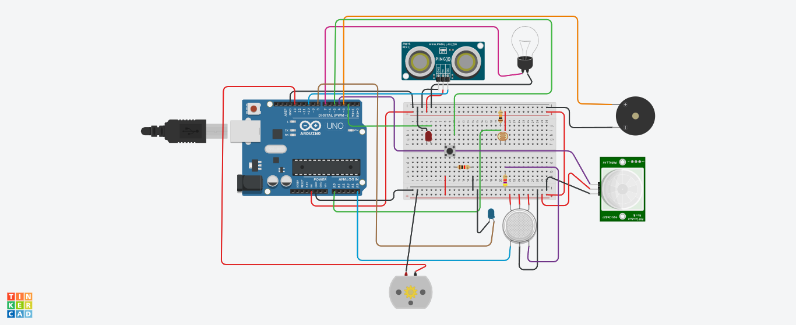

Code :
const int pingPin = 10;
const int ledUS = 2;
const int light = 7;
const int pir = 4;
#define photoSensor A0
#define buzzer 3
int const PINO_SGAS = A5;
int const ledGas = 8;
int const button = 5;
int const motor = 13;
void setup()
{
pinMode(ledUS, OUTPUT);
pinMode(light, OUTPUT);
pinMode(buzzer, OUTPUT);
pinMode(ledGas, OUTPUT);
pinMode(motor, OUTPUT);
pinMode(pir, INPUT);
pinMode(button, INPUT);
pinMode(photoSensor, INPUT);
Serial.begin(9600);
}
void loop()
{
long duration, cm;
int valLight = analogRead(photoSensor);
int valPIR= digitalRead(pir);
int valGAS = analogRead(PINO_SGAS);
valGAS = map(valGAS, 300, 750, 0, 100);
int valBt = digitalRead(button);
pinMode(pingPin, OUTPUT);
digitalWrite(pingPin, LOW);
delayMicroseconds(2);
digitalWrite(pingPin, HIGH);
delayMicroseconds(5);
digitalWrite(pingPin, LOW);
pinMode(pingPin, INPUT);
duration = pulseIn(pingPin, HIGH);
cm = microsecondsToCentimeters(duration);
if(cm < 336){
digitalWrite(ledUS, HIGH);
}else{
digitalWrite(ledUS, LOW);
}
if(valLight < 890){
digitalWrite(light, HIGH);
}else{
digitalWrite(light, LOW);
}
if(valPIR == 1){
digitalWrite(buzzer, HIGH);
}else{
digitalWrite(buzzer, LOW);
}
if(valBt == 1){
digitalWrite(motor, HIGH);
}else{
digitalWrite(motor, LOW);
}
if(valGAS > 20){
digitalWrite(ledGas, HIGH);
}else{
digitalWrite(ledGas, LOW);
}
Serial.print(valPIR);
Serial.println();
}
long microsecondsToCentimeters(long microseconds) {
return microseconds / 29 / 2;
}

Simulation :
